**Thibaut FONTAINE**

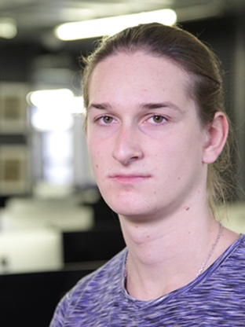

I   
171 boulevard Victor Hugo, apt. 140

Les Estudines Victor Hugo

92110 CLICHY, FRANCE  
Mob : +33 6 52 50 26 87

[tfontain@student.42.fr](mailto:tfontain@student.42.fr)

20 years old, Nationality French

**Internship in AI / machine learning**

Student in the 42 school of Paris

Experience, participation to IT events

i

**05/2017 Winner of the SexTechLab Hackathon**

* 1st place in a Hackathon about innovation in sexuality. Me and my team have created a chatbot, using machine learning, which explains and speak about sexuality to teenagers.

**12/2016 Workshop, and Hackathon by Cisco**

* On the theme of smart cities. Using Datas of the city of Paris, we created a chatbot about tourism and data.

**Since 12/2016 Several conferences and meet-ups (IBM, iHealth, Microsoft, Airbus, etc.)**

**07/2015 Summer job in logistics in a sorting center of letters (La Poste).**

Education

i

**Since 11/2016 42 School – Algorithmic branch**

* Fighting algorithm, combining assembly and virtual machine (Core Wars)
* Algorithm dealing about the theory of graphs, shorter path, etc.
* Other various projects : sorting, display, reading, optimal solution, etc.

**09/2015 - 06/2016 University of Rouen**

* Mathematics and computer science
* Digital Electronics

**06/2015 Blaise Pascal High school - Rouen**

* French Scientific baccalauréat
* Specialization in Engineering sciences and physics

Skills

**IT sector**

Good knowledge of C, Python, Git, and Unix.

Basics in Php/Mysql, Javascript, programming in embedded systems, electronics.

**Spoken languages**

Full professional proficient in English, Fluent in French

Centers of interest

Music, Computer sciences, Cinema, Entrepreneurship